GOOGLE FORM
Form Title:
👉 Cervix-AI Data Collection Proforma
SECTION 1 – DEMOGRAPHIC DETAILS

Study ID: 1

Age (years):32

SECTION 2 – OBSTETRIC & GYNAE HISTORY

Parity:3

Post-coital Bleeding:absent

White Discharge:present

Pelvic Pain:absent

CLINICAL EXAM

Speculum Finding:erosion

CYTOLOGY

Pap Type
- Conventional

Smear Adequacy
- Adequate

Cytology Diagnosis (Bethesda)
- LSIL: Pap showed isolated clusters of cells with nuclear enlargement, hyperchromasia, and distinct perinuclear halos (koilocytosis)

Image ID 1
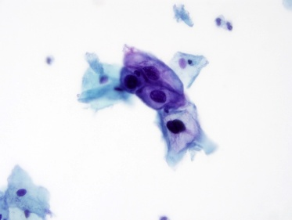

HISTOPATHOLOGY

Specimen Type
- Punch

Histopath Diagnosis
- CIN 1:squamous epithelium with dysplasia in lower one third with koilocytes

Histopath 1

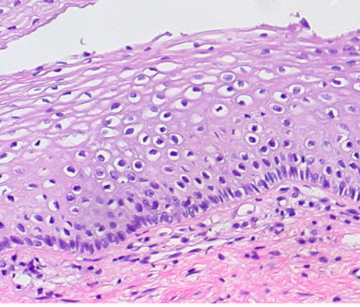

GOOGLE FORM
Form Title:
👉 Cervix-AI Data Collection Proforma
SECTION 1 – DEMOGRAPHIC DETAILS

Study ID:2

Age (years):29

SECTION 2 – OBSTETRIC & GYNAE HISTORY

Parity:2

Post-coital Bleeding:present

White Discharge:present

Pelvic Pain:absent

CLINICAL EXAM

Speculum Finding:erosion

CYTOLOGY

Pap Type
- Conventional

Smear Adequacy
- Adequate

Cytology Diagnosis (Bethesda)
- LSIL: Pap smear showed binucleated squamous cells with mild nuclear atypia and prominent inflammatory background

Image ID :2
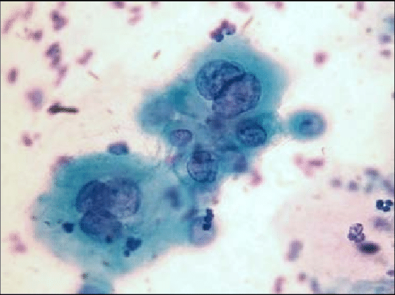

HISTOPATHOLOGY

Specimen Type
- Punch

Histopath Diagnosis
CIN 1:sections studied show squamous epithelium with koilocytes and binucleated cells

Histopath Number:2

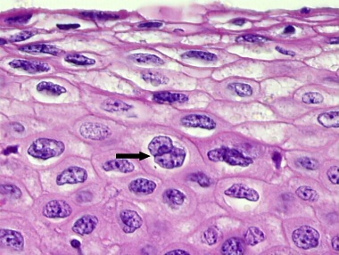

GOOGLE FORM
Form Title:
👉 Cervix-AI Data Collection Proforma
SECTION 1 – DEMOGRAPHIC DETAILS

Study ID: 3

Age (years):32

SECTION 2 – OBSTETRIC & GYNAE HISTORY

Parity:3

Post-coital Bleeding:absent

White Discharge:absent

Pelvic Pain:absent

CLINICAL EXAM

Speculum Finding:erosion

CYTOLOGY

Pap Type
- LBC

Smear Adequacy
- Adequate

Cytology Diagnosis (Bethesda)
- LSIL: smears show mature squamous cells with koilocytotic atypia
- Image ID:3

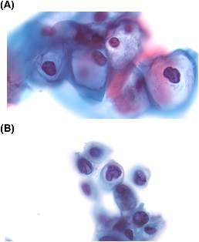

HISTOPATHOLOGY

Specimen Type
- Punch

Histopath Diagnosis
- CIN 2: Squamous epithelium showing dysplasia in 2/3rd epithelium

Histopath Number:3

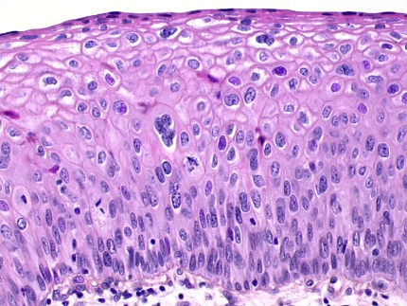

GOOGLE FORM
Form Title:
👉 Cervix-AI Data Collection Proforma
SECTION 1 – DEMOGRAPHIC DETAILS

Study ID: 4

Age (years):30

SECTION 2 – OBSTETRIC & GYNAE HISTORY

Parity:3

Post-coital Bleeding: absent

White Discharge: present

Pelvic Pain: absent

CLINICAL EXAM

Speculum Finding:erosion

CYTOLOGY

Pap Type
- Conventional

Smear Adequacy
- Adequate

Cytology Diagnosis (Bethesda)

LSIL: extensive leukocytic background and a binucleated parabasal squamous cell with mild nuclear enlargement and fine granular chromatin

Image ID:4
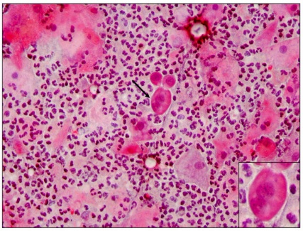

HISTOPATHOLOGY

Specimen Type
- Punch

Histopath Diagnosis

CIN 1: The epithelial changes are characterized by significant nuclear atypia in the superficial half due to extensive koilocytosis and proliferation of basal and parabasal cells.

Histopath Number:4

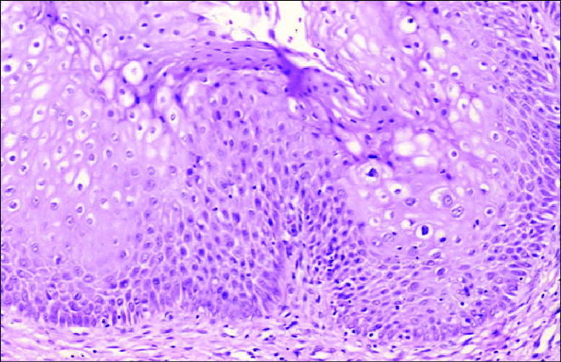

GOOGLE FORM
Form Title:
👉 Cervix-AI Data Collection Proforma
SECTION 1 – DEMOGRAPHIC DETAILS

Study ID: 5

Age (years):42

SECTION 2 – OBSTETRIC & GYNAE HISTORY

Parity:2

Post-coital Bleeding:present

White Discharge:present

Pelvic Pain:absent

CLINICAL EXAM

Speculum Finding:erosion

CYTOLOGY

Pap Type
- Conventional

Smear Adequacy
- Adequate

Cytology Diagnosis (Bethesda)
- HSIL: Pap revealed syncytial-like aggregates of small, immature cells with high nuclear-to-cytoplasmic (N/C) ratios and coarse chromatin,irregular nuclear borders.

Image ID:5

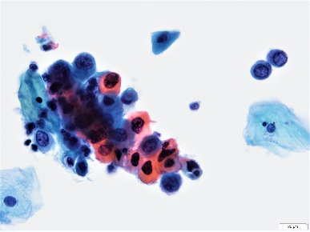

HISTOPATHOLOGY

Specimen Type
- Punch
- LEEP
- Cone
- NA

Histopath Diagnosis
- CIN 3:full thickness dysplasia of squamous epithelium

Histopath Number:5

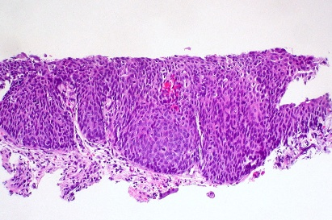

GOOGLE FORM
Form Title:
👉 Cervix-AI Data Collection Proforma
SECTION 1 – DEMOGRAPHIC DETAILS

Study ID: 6

Age (years):38

SECTION 2 – OBSTETRIC & GYNAE HISTORY

Parity:2

Post-coital Bleeding:present

White Discharge:present

Pelvic Pain:absent

CLINICAL EXAM

Speculum Finding:erosion

CYTOLOGY

Pap Type
- Conventional

Smear Adequacy
- Adequate

Cytology Diagnosis (Bethesda)
ASC-H: Pap smear showed cells with irregular nuclear membranes

and coarse chromatin, reactive atypia

Image ID:6
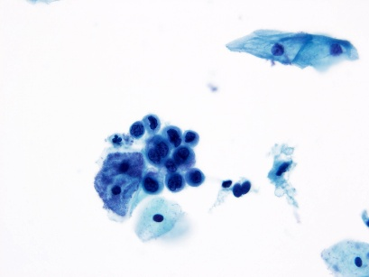

HISTOPATHOLOGY

Specimen Type
- Punch

Histopath Diagnosis
- CIN 2: Squamous epithelium shows dysplasia in upper 2/3rd of epithelium

- Histopath Number:6

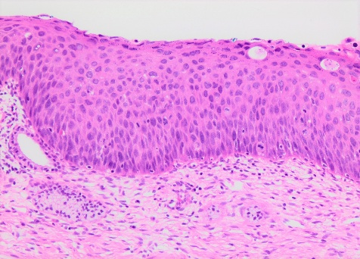

GOOGLE FORM
Form Title:
👉 Cervix-AI Data Collection Proforma
SECTION 1 – DEMOGRAPHIC DETAILS

Study ID: 7

Age (years):45

SECTION 2 – OBSTETRIC & GYNAE HISTORY

Parity:3

Post-coital Bleeding:absent

White Discharge:present

Pelvic Pain:absent

CLINICAL EXAM

Speculum Finding:erosion

CYTOLOGY

Pap Type
- Conventional

Smear Adequacy
- Adequate

Cytology Diagnosis (Bethesda)
- HSIL; smears show crowded sheets of basal type of cells with high N/C ratio

Image ID:7
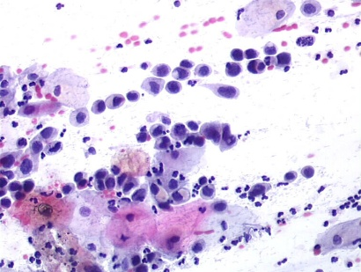

HISTOPATHOLOGY

Specimen Type
- Punch

Histopath Diagnosis

CIN 3: The epithelium lacks maturation and consists of small highly atypical cells with hyperchromatic nuclei

Histopath Number: 7

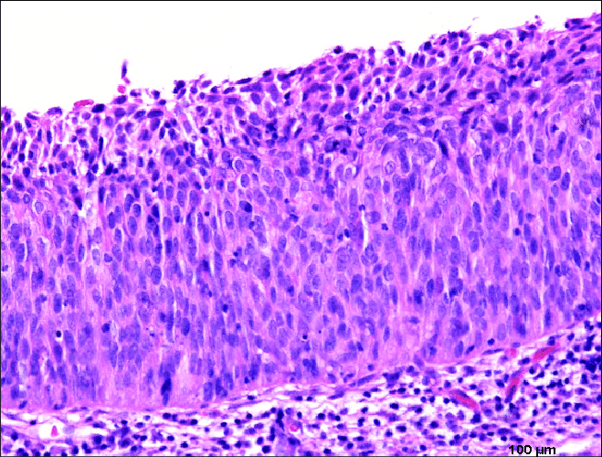

GOOGLE FORM
Form Title:
👉 Cervix-AI Data Collection Proforma
SECTION 1 – DEMOGRAPHIC DETAILS

Study ID: 8

Age (years):50

SECTION 2 – OBSTETRIC & GYNAE HISTORY

Parity:3

Post-menopausal Bleeding:present

White Discharge:present

Pelvic Pain:absent

CLINICAL EXAM

Speculum Finding:erosion with induration

CYTOLOGY

Pap Type
- Conventional

Smear Adequacy
- Adequate

Cytology Diagnosis (Bethesda)
- HSIL: Pap smear showed diathesis (necrotic background), bizarre, keratinized malignant cells with pleomorphic nuclei.

Image ID:8
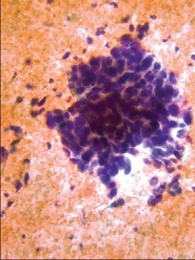

HISTOPATHOLOGY

Specimen Type
- Punch

Histopath Diagnosis
- Invasive Squamous cell carcinoma

Histopath Number:8

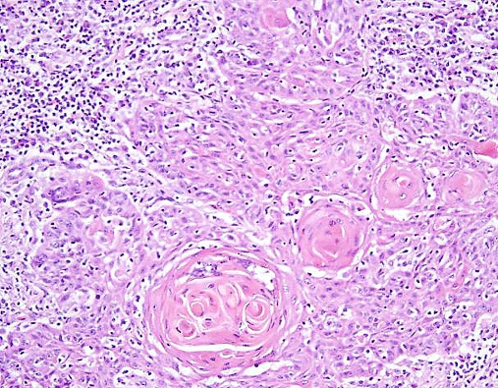

GOOGLE FORM
Form Title:
👉 Cervix-AI Data Collection Proforma
SECTION 1 – DEMOGRAPHIC DETAILS

Study ID: 9

Age (years):55

SECTION 2 – OBSTETRIC & GYNAE HISTORY

Parity:3

Post-menopausal Bleeding:present

White Discharge:present

Pelvic Pain:absent

CLINICAL EXAM

Speculum Finding:mass in cervix

CYTOLOGY

Pap Type
- Conventional

Smear Adequacy
- Adequate

Cytology Diagnosis (Bethesda)
- HSIL: pap smear showed tumor diathesis and tadpole cells.

Image ID:9
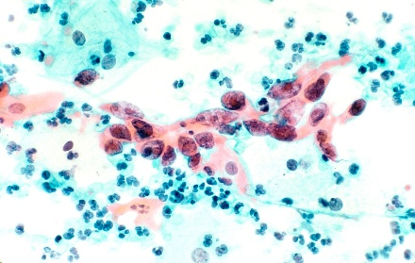

HISTOPATHOLOGY

Specimen Type
- Punch

Histopath Diagnosis
- Invasive keratinizing squamous cell carcinoma
- Histopath Number:9

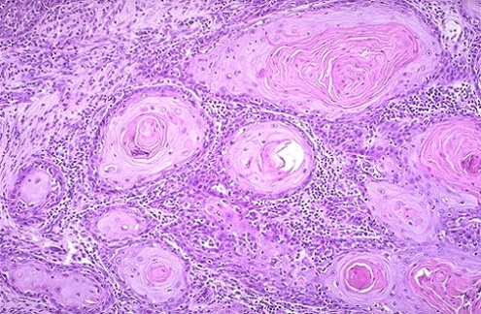

GOOGLE FORM
Form Title:
👉 Cervix-AI Data Collection Proforma
SECTION 1 – DEMOGRAPHIC DETAILS

Study ID: 10

Age (years):60

SECTION 2 – OBSTETRIC & GYNAE HISTORY

Parity:3

Post-coital Bleeding:absent

White Discharge:present

Pelvic Pain:absent

CLINICAL EXAM

Speculum Finding:cervical mass

CYTOLOGY

Pap Type
- Conventional

Smear Adequacy
- Adequate

Cytology Diagnosis (Bethesda)
- SCC: Pap smear showed highly abnormal, irregular cells with massive, pleomorphic nuclei, indicating high-grade malignancy

Image ID:10
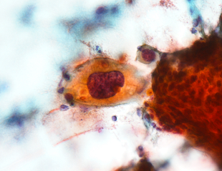

HISTOPATHOLOGY

Specimen Type
- Punch

Histopath Diagnosis
- Invasive squamous cell carcinoma

Histopath Number:10

